Lab 6:
Loop Statements

Learning outcome:
At the end of this lab, student should be able:
- Construct program by using repetition statement (P4)

Instructions: | - For submission, the students should produce:  - the PAC  - the flowchart  - the source code (Java program)  - In the source code, use comments to state your matric number, name, program, and lab assignment number (e.g. Lab 6), etc...
Submission Date: 5 Jun 2026

Questions:

- Develop a Java application to calculate the entrance fee for visitors to the Zoo Negara. Each visitor requires an entrance ticket. But the entrance fee calculation and payment should be based on payment receipt.

Each payment receipt will specify the total payment that may comprise one or more tickets from different visitor categories. For example, a receipt may comprise tickets payment for 2 adults, 3 children and a senior. So the application should allow user to calculate the fee for multiple tickets and accumulate the total to produce a single receipt for payment.

The entrance fee should be processed based on the criteria described in the following table:
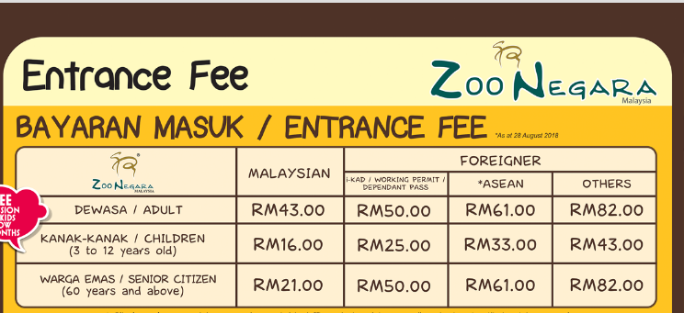

The user (staff) should be allowed to calculate the ticket price by visitor category. User will input the nationality (Malaysian, or Foreigner that could be I-Kad/Working Permit/Dependent Pass, ASEAN, or Others), visitor category (Adult / Child / Senior), and number of tickets required for the category. Then the application shall process and display the total fee. The user should be allowed to calculate for more tickets until user want to stop and calculate the total payment for receipt. After a receipt information is produced, the user will be given an option to continue to produce another receipt or exit from the application. See Sample Output below for example of user interaction.

Sample output:

ZOO NEGARA ENTRANCE TICKET PAYMENT SYSTEM

******VISITOR*******

Enter nationality: M
Choose category of visitor
(A- Adult, C - Children, S - senior):A
Number of tickets:2
Total is RM 86.00

Buy more ticket (Y/N)?: Y

Enter nationality: M
Choose category of visitor
(A- Adult, C - Children, S - Senior):C
Number of tickets:1
Total is 16.00

Buy more ticket (Y/N)?: N

The total payment for receipt is RM102.00

Process another visitor (Y/N)?: Y

******VISITOR*******

Enter your nationality: M
Choose category of visitor
(A- Adult, C - Children, S - Senior):A
Number of tickets:2
Total is RM86.00

Buy more ticket (Y/N)?: N

The total payment for receipt is RM86.00

Process another visitor (Y/N)?: Y

******VISITOR*******

Enter your nationality: F
Enter classification
(I- Kad/Working Permit/Dependent Pass, E- Asean, O- Others):I
Choose category of visitor
(A- Adult, C - Children, S - Senior):A
Number of tickets:2
Total is 100.00

Buy more ticket (Y/N)?: Y

Enter your nationality: F
Enter classification
(I-Kad/Working Permit/Dependent Pass, E- Asean, O- Others):E
Choose category of visitor
(A- Adult, C - Children, S - Senior):A
Number of tickets: 1
Total is RM61.00

Buy more ticket (Y/N)?: N

The total payment for receipt is RM161.00

Process another visitor (Y/N)?: N

Application finish.

